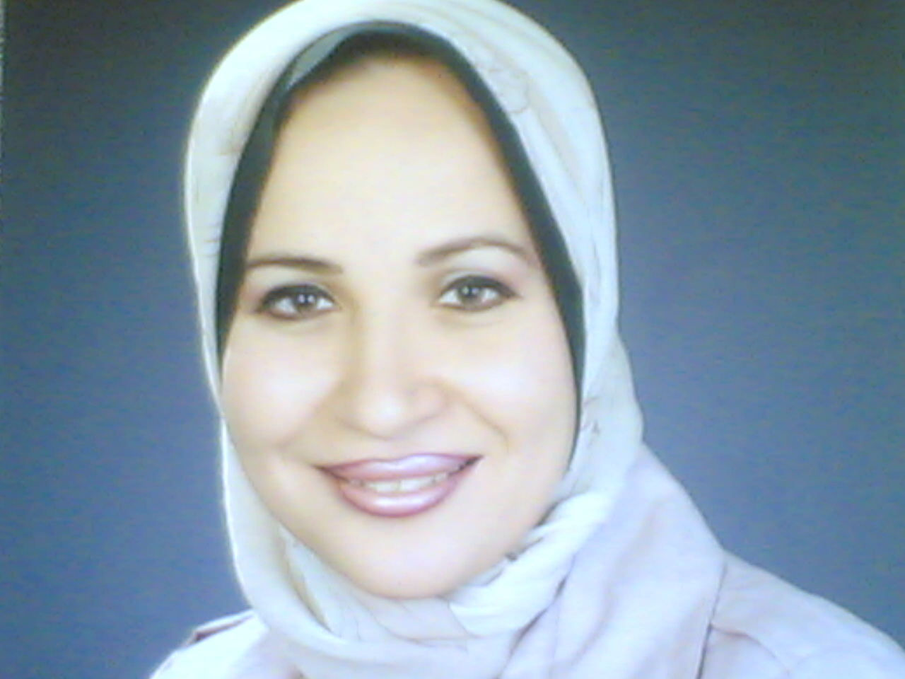 | Name Naglaa Kamal A. Idriss  First Middle Last
Date of Birth | 10/19/1972 Place of Birth : Assiut (EGYPT)
Nationality | Egyptian
Mailing address | Chemistry Dep. Faculty of Science  Assiut University, Assiut 71516  C/O Prof. Kamal Idriss
Work Address | Department of Medical Biochemistry  Faculty of Medicine Assiut, University  Assiut 71516, Egypt
Academic Qualifications:  (M.B.B Ch), 1996  M.Sc, 2002  MD, 2009 | Faculty of Medicine Assiut University  In Medical Biochemistry on 30 June, 2002.  The Title of thesis was:  Role of Apoptosis in Acute Lung Injury.  The grades were:  First part in April 2000, was excellent  Research in February 2002, was excellent  The second part in May 2002 was very good and the general grades were excellent. Faculty of Medicine Assiut University  In Medical Biochemistry  The Title of thesis was:  Haemoxygenase and angiogenesis in acute myocardial infarction on  Research in June 2008 and the second part in June 2009. Faculty of Medicine Assiut University
Current Position | Lecturer , Department of Medical Biochemistry –Faculty of Medicine, Assiut University Egypt  Specialty Medical Biochemistry  Subspecialty: Cardiovascular basic science and cell biology
Phone | 002 088 2314329, 002 088 2332219  Mobil : 0020103830234
Fax | 002 088 02142708
E -mail | naglaaidriss@hotmail.com
Academic Positions | - Lecturer, Department of Medical Biochemistry, Faculty of Medicine, Assiut University, 2009  - Assistant Lecturer, Department of Medical Biochemistry, Faculty of Medicine, Assiut University, 2002  - Demonstrator, Department of Medical Biochemistry, Faculty of Medicine, Assiut University, 1998
Marital Status | Married  Dr /Sherif Sayed Abdel Rehim
Nature and place of work of Husband | Assistant Professor, Department of  Anesthesia Faculty of Medicine. Assiut University  Egypt
Training in Haemeostasis Thrombosis and Vascular Biology Laboratory.UK, Birmingham | Under the direction and supervision.  of Prof Gregory Lip Prof of Cardiovascular medicine and Dr Andrew Blann  Senior Lecturer of Haematology. University Department of Medicine City Hospital, Birmingham, B18 7QH, United Kingdom this included:  - Lab work started at August 2006  - Training for all assays in HTVB lab  - Tissue culture of human umbilical vein endothelial cells with and without TNF (n.b. this also included obtaining umbilical cords from the Maternity Suite),started at 1/3//2007finsihed at 5/12/2007  - Training on SOP of Preparing cell Tissue culture of human umbilical vein endothelial cells for ELISA assays 1/3//2007finsihed at 5/12/2007  - Training on SOP of Preparing palatals for ELISA assays 1/11/2007 finished at 1/12/2007  - ELISAs of plasma for HO-1, VEGF, angiogenin, MMP-9 and TIMP-1  - Preparation of HUVEC and platelet lysates, and the ELISA of these lysates for HO-1, angiogenin and von Willebrand factor.
Abstracts Related to Ph.D Thesis  Accepted for Presentation at International Meetings  Abstracts NOT Related to Ph.D Thesis Accepted for Presentation at International Conferences | - Systemic and intracardiac serum levels of Haemoxygenase-1 in patients with coronary artery disease: relationship to severity of cardiovascular diseases.  Idriss NK, Jaumdally RJ, Boos CJ, Balakrishnan B, Blann AD, MacFadyen RJ, Lip GYH.  Arteriosclerosis Thrombosis Biology Meeting Atlanta. USA, April 16th 2008.  - Transcardiac sampling of Biomarkers of extracellular matrix turnover and angiogenesis: Impact of acute coronary syndrome.  Idriss NK, Jaumdally RJ, Boos CJ, Lane DA, Blann AD, MacFadyen RJ, Lip GYH.  Arteriosclerosis Thrombosis Biology Meeting Atlanta. USA , April 16th 2008.  - Haemoxygenase-1 in coronary artery disease: a comparison with angiogenin and vascular endothelial growth factor.  Idriss NK, Jaumdally RJ, Boos CJ, Balakrishnan B, Blann AD, MacFadyen RJ, Lip GYH.  Cardiovascular Research Day. Queen Elizabeth Hospital. Birmingham UK, March 19th 2008.  - Indices of angiogenesis and extracellular matrix turnover in relation to coronary artery disease severity.  Idriss NK, Jaumdally RJ, Boos CJ, Lane DA, Blann AD, MacFadyen RJ, Lip GYH.  Medical Research Society. London UK, February 28th 2008  - Haemoxygenase-1 levels in coronary artery  disease: a comparison with angiogenin and vascular endothelial growth factor.  Idriss NK, Jaumdally RJ, Boos CJ, Balakrishnan B, Blann AD, MacFadyen RJ, Lip GYH. European Society of Cardiology. Munich.Germany, August 31st 2008  6. Effect of Angiopoietin-1, Angiogenin , Insulin like growth factor-1 and Nitric oxide on tumor angiogenesis in Lung cancer. Idriss NK ,Abdelrehim SS , ZakharyMM, Hassen HA. Egyptian Malaysian oncology hand to hand ,Kulalumpur-28/4:4/5 -2010  7. Extracellular matrix turnover, angiogenesis and endothelial function in acute lung injury: Relationship to pulmonary dysfunction and outcome. Naglaa K driss,² Sherif Sayed¹, Hyaim. G Sayyed³ ¹Anaesthesiology, ²Medical Biochemistry and Medical Physiology , Sepsis Conference 7 November,Paris ,France 2012  8.Comparison Between Circulating Endothelial Cells and Platelet Microparticles Levels in Egyptians Rheumatic Mitral Diseases with and without Atrial Fibrillation. Naglaa K Idriss, Douaa M Sayed, Hosny A Hasan, YehiaT Keshek, Marwa M Abdelnaem Medical Biochemistry Department , Acute Cardiac Care ,Istanbul, Turkey, 20 October 2012  9. Comparison between serum levels of retinol binding protein-4 and total thiols in generalized obesity and abdominal obesity regarding cardiovascular risks.Naglaa K Idriss, Ahmed A Abdelgelil, Salwa R Dimitry, Eman A Abbas, Acute Cardiac Care ,Istanbul, Turkey, 20 October 2012  10 .Plasma levels of soluble receptor for advanced glycation end products (sRAGEs) and oxidized low density lipoprotein (oxLDL) in pediatric heart failure: relationship to the severity of diseases. Sherif S Abdelrehim,  Naglaa K Idriss, Duaa M Raafat, Duaa A Fouad, Mostaf M Shafek., Acute Cardiac Care, Istanbul, Turkey, 20 October 2012  11. Association between monocytic tissue factor (CD 142) expression, diabetes and antidiabetic therapy in hepatitis C-related liver cirrhosis  Mona Abu'elmakrem, Mohammed Eslam , Douaa Sayed, Mohamed Shawkat, Naglaa K. Idriss, Hesham Abdelhailm, Mohammed A. Sahrawy, Elwy M. Soliman , Sahar H. El-Hini  63rd Annual Meeting of the American-Association-for-the-Study-of-Liver- Diseases (AASLD), Boston, MA, NOV 09-13, 2012, USA  12. Heme oxygenase-1(HO-1) gene expression and plasma levels of Hypoxia inducible factor -1 alpha (HIF-1α) after valve replacement surgery in patients with rheumatic heart diseases. Sherif Sayed,  Naglaa Idriss, Amr Ashry, Amany Osma EuroTHROMBOSIS Uppsala Sweden October 3-5 / 2013  13. Comparative study between the effects of human CD34+ and rat bone marrow mesenchymal stem cells on amelioration of CCL4 induced liver fibrosis. Amany Osama,  Naglaa Idriss, Dina Sabry , Mona Magdy ”(FEBS_EMBO-Paris30 August -2 September2014)
  “

LOCAL AND INTERNATIONAL CONFERECES HAD BEEN ATTENEDED
- The Second scientific congress of medical Biochemistry department – Faculty of medicine – Assuit University March 16-17 2009
- The annual scientific conference –Ain shams University Guest House , Cairo Egypt May 1-2,2014
- First Integrated Medicine Conference : Lungs In The Core 10-12October 2012
- International Annual Conference of Tropical Medicine and Gastroenterology Department – Faculty of medicine – Assuit University 20-23 November 2013
- 27th annual conference –Faculty of medicine – Assuit University 28-31 March 2009
- Second Annual conference of integrated medicine and sleep disorders society-Assuit University 13-15 November 2013
- International Meeting of the 58the of scientific congress of ESCC. Main Theme Laboratory Medicine and genomic Update 27-28 November 2013 Cairo, Egypt Cairo Hotel, Zamalek , Egypt
- The annual scientific conference –Ain shams University Guest House , Cairo Egypt April 19-20, 2012 Cairo Egypt
- International Annual Conference of hepato-Gastroenterology, April4-5 , 2013 Luxor, Egypt
- 29th annual conference , Faculty of medicine- Assiut University, 23-26 December 2012
- International Sepsis Forum, Sepsis 2013 , Paris Novemebr7-9 2012
- 5th Annual scientific conference, Faculty of medicine, Assuit, Egypt 5May, 2011
- International Meeting of the 57the of scientific congress of ESCC. Main Theme Latest Advance in chronic diseases(cardiovascular, diabetes, thyroid disorders) laboratory prospective 4-5 December, 2010 Cairo , Egypt Cairo Marriott Hotel , Zamalek , Egypt
- International annual conference of Assuit clinical oncology department Best of oncology 26th February -1st March 2014
- 13th Annual scientific conference of gastroenterology and liver diseases 21-22 March 2012 , Assuit University , Faculty of medicine
- 30th Annual scientific conference of 26-29 April 2014 , Assuit University , Faculty of medicine
- International conference of 1st Malaysian Egyptian oncology conference HAND IN HAND AGAIST CANCER ,1st-2 May 2010 in Kuala Lumpur Malaysia
- Biochemistry and molecular biology ‘present and Future’ESBMB April 14-15, 2010
- Assuit Digestive disease week November 8th-11th 2010 , Assuit University
- International conference of European society of cardiology : Acute cardiac Care 20 October-22,2012 Istanbul-Turkey
- 2nd medical congress in upper Egypt 2-3 April 2014
- Molecular Clinical Biochemistry Updates , Kasar Al-Ainy Faculty of medicine , Cairo University . 22 March,2014
- Fundamentals of endocrine disorders and diabetes , Assuit University , Fcaulty of medicine 9th-10th April 2014
- Euro-thrombosis Summit2013 , held in Uppsala , Sweden 3-5 October, 2013
- FEBS_EMBO-Paris30 August-2 September2014

Certificates of Memberships
- Member of International society for stem cell research (ISSCR)
- Member of the Acute cardiovascular care association Year 2012
- Member of the Acute cardiovascular care association Year 2013
- Member of the Acute cardiovascular care association Year 2014
- Member of the European society of cardiology ESC Working group on Coronary pathophysilogy and microcirculation Year 2013
- Member of the European society of cardiology ESC Working group on Thrombosis Year 2013
- Member of the European society of cardiology ESC Working group on Thrombosis Year 2014
- Member of Egyptian society of clinical chemistry
- Member of Heart Failure Association of ESC (HFA)Year 2014
- Member of Society of heart valve diseases (SHVD)

Awards
- Prof Soliman Hozin Prize in excellent and qualifies scientific research activities 2012/2013
- Certificate for achievement and success on coordinator the course specifications of Medical Doctorate and Master degree programs in medical biochemistry

Reviewer:
- Basic Research Journal of Microbiology Reviewer of the Journal of Microbiology.(jmb@basicresearchjournals.org) and contributed immensely to the growth of the journal by reviewing of the article (Homology modeling and molecular docking study of phytoligands with β-hexosaminidase of Vibrio Cholerae) JMB-29-14.
- Assessor and Evaluator for research proposal at medical ethics committee since 2012 till now

Workshops Has successfully attended
- Stem cells Biotechnology :Isolation, labeling and identification at Molecular and Clinical Biochemistry Updates on 23-24 March 2014, Kasr- Aliny Faculty of medicine, Cairo University.
- Basic technique of human and animal cell culture , educational and training workshop , Faculty of science , Assuit University ,20-23 November 2010
- Stem cells workshop at learning resource center , Kasr Aliny Faculty of medicine, Cairo University 30 March 2013
- Advanced Theoretical and practical Topics in Molecular Biology Filed ( PCR Types and DNA Sequencing) at molecular biology research unit , Assuit University , Faculty of medicine 16 December -18, 2013

Practical Skills:

- Regular practical Medical Biochemistry ;
- Tissue Culture Biology :
  - Human umbilical endothelia cell culture
  - Cell line culture
  - Stem cell culture
- Enzyme linked immunoassy manufacturing.
- Molecular Biology .

Previous employment:

Fellowship:2006-2008

• Fellowship in Cardiovascular science (2 years), Birmingham University, City hospital - Haemostasis Thrombosis & Vascular Biology Unit. Cardiovascular and Respiratory Sciences Birmingham –England

- Publications:
- Plasma haemoxygenase-1 in coronary artery disease. A comparison with angiogenin, matrix metalloproteinase-9, tissue inhibitor of metalloproteinase-1 and vascular endothelial growth factor. Naglaa K Idriss, Gregory Y H Lip, Balu Balakrishnan, Rumi Jaumdally, Christopher J Boos, Andrew D Blann. Journal of Thrombosis and Haemostasis (impact factor: 5.731). 11/2010; 104(5):1029-1037.

Hemoxygenase-1 in Cardiovascular Disease.Naglaa K Idriss, Gregory Y H Lip, Andrew D Blann Journal of the American College of Cardiology (impact factor (14.156),Volume 52, Issue 12, Pages 971-978, 16 September 2008,

- Extracellular Matrix Turnover, Angiogenesis and Endothelial Function in Acute Lung Injury: Relation to Pulmonary Dysfunction and Outcome . Naglaa Kamal Idriss, Sherif Sayed, Hayam Gaber Sayyed , No 5 (2012)page 171-182 Ibnosina J Med BS

- Effect of Vagus Nerve Stimulation on Focal Transient Cerebral Ischemia and Reperfusion in Adult Male White New Zealand Rabbits . Hayam Gaber Sayyed, Naglaa Kamal Idriss, Abeer Mostafa Darwish, Ibnosina Journal of Medicine and Biomedical Sciences Vol 5, No 2 (2013) page 73-82

- Role of Angiogenic Biomarkers in Gastrointestinal Cancer," Sahar EM El-Deek, Naglaa Kamal Idriss, Randa S Hana, Madleen AA Abdou, Doaa W Maksemose, Madeha M Zakhary Ibnosina Journal of Medicine and Biomedical Sciences Vol 5, No 4 (2013) 196-205

- Implication of tumor necrosis factor-alpha receptor-1 and hexosaminidase : relationship to pathogenesis of hepatocellular carcinoma. Idriss NK, Sayyed HG , Zakhary MM, Sherif Sayed. Comparative clinical pathology journal 2013;13: 1747-1751,

- Relationship of angiogenin to pathophysiology of diseasesNaglaa K. Idriss, Sherif Sayed, Madeha M. Zakhary, Hosney A. Hassen Comparative clinical pathology journal 2013;13: 1378-1384

- The effect of melatonin on serum pentraxin-3, total thiols and lipid peroxides, and nuclear factor-kappa beta immunohistochemical expression on acetic acid-induced colitis in the rat Hayam G Sayyed, Rumi Jaumdally, Andrew D Blann Naglaa K Idriss, Dalia A El Sers Digestive Diseases and Sciences ISSN 0163-2116 Volume 58 Number 11 Dig Dis Sci (2013) 58:3156-3164

- Comparison between Circulating Endothelial Cells and Platelet Microparticles Levels in Egyptians Rheumatic Mitral Diseases with and without Atrial Fibrillation Naglaa K Idriss¹, Andrew D Blann ,] Rumi Jaumdally, Douaa M Sayed², Hosny A Hassen¹ ,Yehia T Keshek³, Marwa A Gaber¹ .Angiology journal 2014

- Plasma Levels of Soluble Receptors of Advanced Glycation End Products, Angiogenin, and Hypoxia Inducible Factor-1 Alpha in Acute Coronary Syndrome . Doaa Fouad, Naglaa Idriss, Sherif Sayed , HearT Mirror J 2013

- Diabetes worsening of hepatitis C Cirrhosis Are alterantions of monocytic tissue factor (CD 142) is the cause ?Mona Abu'elmakrem Mohammed Eslam Douaa Sayed Mohamed Shawkat Naglaa K. Idriss Hesham Abdelhailm Mohammed A. Sahrawy Elwy M. Soliman Sahar H. El-Hini. Annals of hepatology, 2014 , vol 13: 27-37

- Circulating retinol binding protein-4 and total thiols in generalized and abdominal obesity regarding; monitors of cardiovascular disease Salwa R Dimitry¹, Naglaa K Idriss ,Ahmed Abdel-Galeel ¹, Eman A Abdel Aal¹. Egyptian Bulletin j of biochemistry and physiology,2013

- Genetic polymorphism of CCR6-rs2301436 increases susceptibility of HCC and promotes tumor progression in HCV-G4 infected Egyptian patients submitted to Life Sciences Mona Abuel Makarim: Rania M Bakry; Naglaa K Idriss; Ahmed Amin; Mahmoud R Mohamed ; Mohamed E Shatat; Atef El-Akad; Elwy M Soliman; Raga Matta,SUBMITTED TO LIFE SCIENCE J

- Comparative study between the effects of human CD34+ and rat bone marrow mesenchymal stem cells on amelioration of CCL4 induced liver fibrosis SUBMITTED TO STEM CELL J

Accepted projects from postgraduate studies and scientific affairs Ethics, Ethics Review Board Faculty of Medicine Assuit University. Faculty of Medicine Grant's Office

- Novel Biomarkers in Pediatric Heart Failure 2010. As a principle investigator,
- Diffusion Weighted MRI and Novel Biomarkers in appraisal of liver fibrosis in Hepatitis C Patients 2013. As a senior researcher

Thesis’s Supervisor:

- MD: Marwa A Gaber ; Biomarkers of Endothelial Dysfunctions and Platelets Micro particles in Patients with Atria Fibrillation
- MSc: Eman A Abass; Retinol Binding Protein -4 in generalized and abdominal obesity regarding cardiovascular risk factors
- MSc: Sayed Mohammed Shelbia : The impact of a training program on the concentration of lactic acid in the blood and the effectiveness of performance skills at first-class boxers
- MSc: Mohammed Abed Hamada Hassen : The Effect o f specific trainings on some physical variables and the percent of lactic acid concentration in blood and the efficiency of the skillful performance for judo beginners.
- MD: Hossam mahmoud abd elwahab mohamed Hepatocellular carcinoma;Epidemiology and New Biomarkers for early detection :Hospital based study

References:

Prof. Ahmed Makhalof .
Dean of Faculty of Medicine

Assiut University
Phone: 002 088 2332278

Fax : 002 088 2332278

Prof . Hosney A. Hassan
Professor of Medical Biochemistry
Faculty of Medicine .Assiut University

Prof. Madeha M. Zakhary
Professor of Medical Biochemistry
Faculty of Medicine .Assiut University

- Prof Kamal A Idriss
Professor of Analytic chemistry
Faculty of science Assuit University

